Time Dependent Info Object

Содержание

Back to Basics … What is the KEY DATE ?
My

Исх. DateStart = 08/29/2007

При загрузке это преобразуется в две записи –

DATEFROM DATETO

01/01/1000 DateStart - 1

DateStart 12/31/9999

https://answers.sap.com/questions/73811/language-and-time-dependent-info-object-mapped-to.html

http://www.igniteideasandinspirations.com/question/time-dependent-info-object/

− I have an extractor that extracts data with DATEFROM and DATETO for the time dependent HR employee related data for managers. But when it extracts into BI and loaded to Info Object the DATEFROM is not the same as what is extracted, it is 01/01/1000 instead of record specific. Any idea why it is showing like it is?
− That is the system generated record, you will always have one record starting from 01/01/1000 to the { actual date from – 1 } for time dep. master data.

Example

Date From - Date To
01/01/1000 - 08/28/2007 /System Generated/
08/29/2007 - 12/31/9999 /Actual maintained in the source system/.

Time-Dependent Master Data

https://wiki.scn.sap.com/wiki/display/BI/Time-Dependent+Master+Data

BW characteristics can have -
- Time-dependent Texts
- Time-dependent Attributes
- Time-dependent Hierarches /this topic is discussed here.../

Once time-dependency is used for texts/attributes of chracteristics, it is possible to define the validity of text or attritbute value by maintaining the corresponding DATEFROM and DATETO fields. The latter /'lætə последний/ fields are getting added automatically once time-dependency is active.
When executing a query time-dependent text/attribute values will be displayed in accordance to the key date used by the query. The query key date to be used can be defined during query design time.

Time-dependent Texts – Example

- Transaction RSD1 /in newer releases BWMT is to be used/
- Display e.g. delivered Characteristic 0COSTCENTER

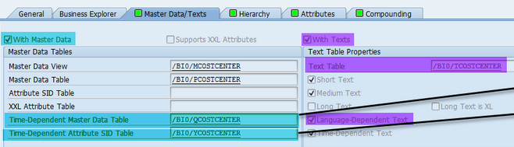

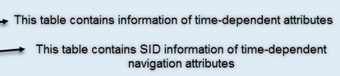

Text Table /BI0/TCOSTCENTER

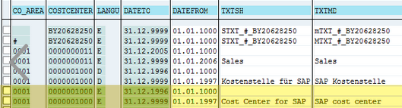

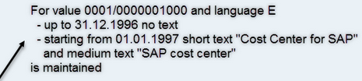

Query Example

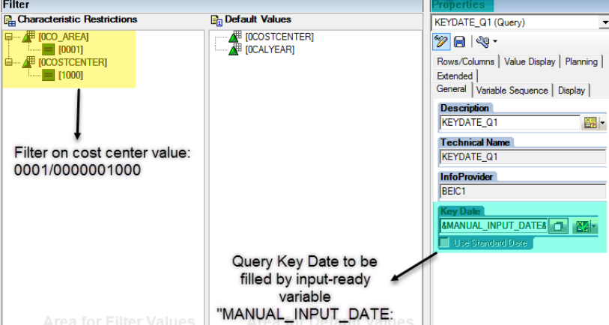

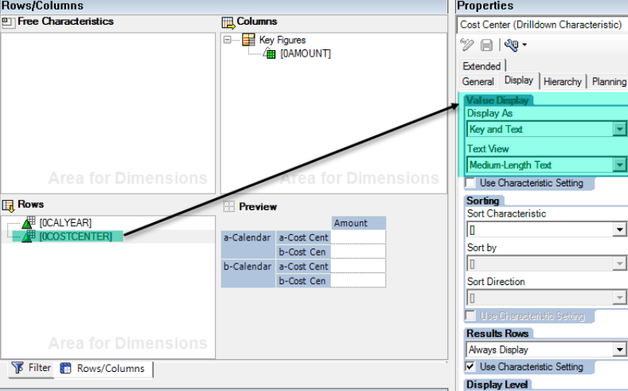

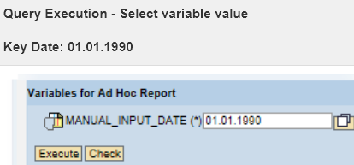

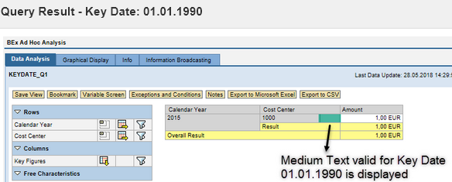

2. Time-dependent Attributes - Example

Tab Attributes

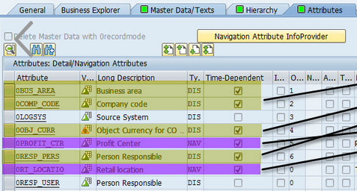

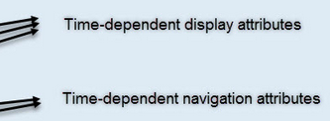

Table /BI0/QCOSTCENTER containing time-dependent attributes

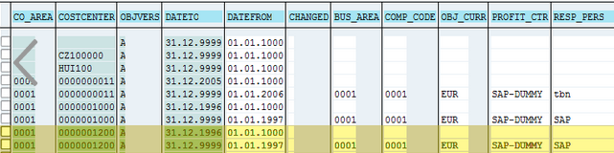

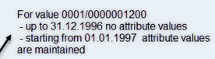

Query Example

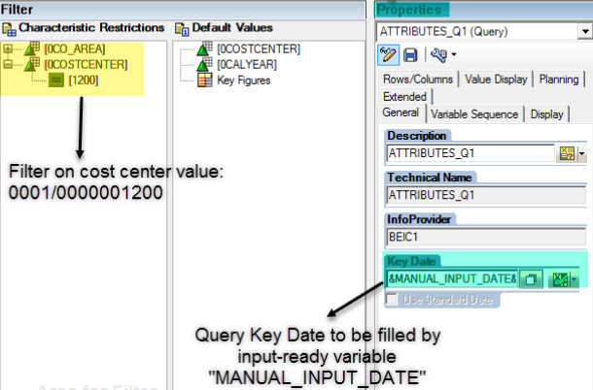

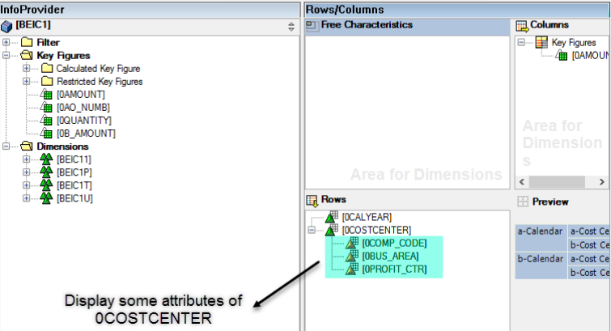

1 - Reporting on Time Dependent Info Object

− I have a Time Dependent Info Object. I need to check for a date to lie between the validity period of the time dependent Info Object. My problem is that how do I check this condition since I don’t see the date to and date from in Bex?
− I understand that you have info-object A where each record is "active" from timeA to timeB. You want to have in BEx report variable screen that can do something like that - you enter dateA and on report occurs those records for object A is "active /where dateA between timeA and timeB/.
So I would try something like that -
1) Сreate date from - timeA and date to - timeB as navigation attributes
2) Then create in BEx variables for them and in selection screen I would allow options -
timeA <= dateA <= timeB

− In the case of Time dependent Info Objects the To and from Dates are not attributes and hence are not accessible in BEx. The system automatically validates the record against the Key Date for the query and picks up the valid record.
But in my case the dateA as you mentioned is an Info Object and I needed to validate it for each record which can be done only if I can get the to and from dates in my query definition.
− You are looking for a variable key date. There is a How To .. guide on that but it basically translates to using Virtual characteristics / Key Figures. The logic for the virtual InfoObject would lookup the value of the time dependent InfoObject based on the variable date.

_ Ashish
I was able to include the dates by creating an Infoset between the ODS and Info Object.
It automatically gets those dates in the query and I was able to apply the condition.

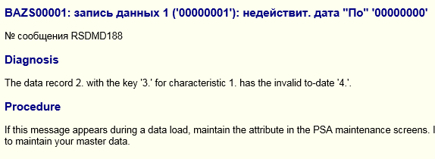
time dependent info object
The data record 2. with the key '3.' for characteristic 1. has the invalid to-date '4.'.

Back to Basics … What is the KEY DATE ?

Содержание

Characteristics can contain attributes, which help describe in detail information about the characteristic itself.
When attributes are assigned to a characteristic, we can add these attributes to our reports in the BEx Analyzer. When we run the report, the BW system reads the attribute values that correspond to the characteristic and displays them in our query results.
When attributes are assigned to characteristics, there is an option to specify that the attributes are Time Dependant. This means that instead of the BW system reading a single attribute value that corresponds to the characteristic, the system has to use dates to workout if the attribute value is valid for the reporting time period the user has chosen when running the report. This is made possible because when Time Dependant data is loaded into a BW system for a characteristic, a start-date and end-date is loaded with it identifying when an attribute is valid. Know when a query is executed that displays attribute information; the BW system needs to know what date to use when searching for the relevant attribute information. This is where the Key Date comes in. BW uses the Key Date as a special parameter to read the relevant attribute records that correspond to the characteristic. You may have designed queries in the past that use attributes but have never specified a Key Date and found that sometimes the correct information is displayed and other times it isn’t. This is because by default the query will use the current system date to find the attribute information if no Key Date is specified for the query, resulting in only the most recent attribute data being displayed. To ensure your reports display the correct attribute information all the time, make sure you either manually specify the Key Date in your query design or use a variable to determine the date at run-time. This can be done by selecting the Query Property screen from within the Query Designer.
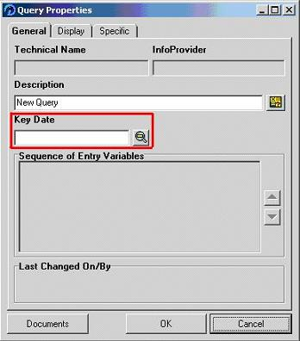
My preferred method is to always display a parameter that the user must fill when the report is executed.

Time-dependent attributes and language-dependent texts in ABAP CDS views

http://sapabapcentral.blogspot.com/2017/09/time-dependent-attributes-and-language.html

My

Содержание

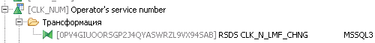

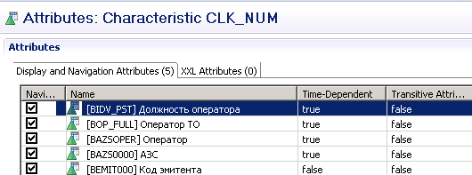

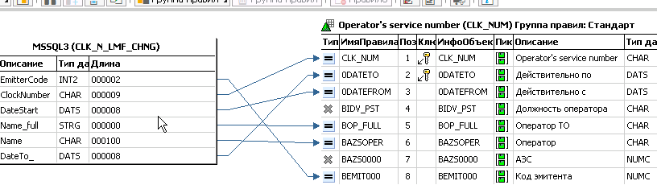

dwbeloil.dbo.ClkN_CHNG
SELECT DISTINCT
org.EmitterCode, stf.ClockNumber,
stf.UIDIndividual, stf.UIDDepartment, stf.UIDPost, stf.IdBase
FROM (SELECT e.* FROM CHANGETABLE(CHANGES KISjoinMDM.KIS.Staff, 0) AS C
LEFT OUTER JOIN KISjoinMDM.KIS.Staff AS e
ON e.UIDDocument = c.UIDDocument AND e.Line = c.Line
) AS stf
LEFT OUTER JOIN KISjoinMDM.KIS.Organization AS org
ON org.IdBase = stf.IdBase
WHERE (org.EmitterCode IS NOT NULL)

dwbeloil].[dbo].[ClkN_LMF_CHNG]

